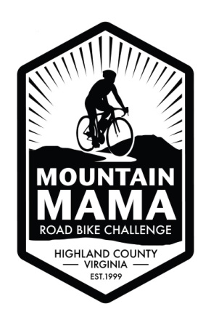
Office Use
Road ID #

Mountain Mama Road Bike Challenge
August 5, 2017 -Monterey, VA

Last Name | First Name |  | M. |  | Age
Address | City |  | State |  | Zip
Home Phone | Mobile Phone |  | Male |  | Female
E-mail Address | Emergency Contact Name |  | Contact #
Ride Options (circle one) |  | T-Shirt Size (circle one) *
Century ride 100 miles** |  | Small
2 State long ride 70 miles** |  | Medium
2 State short ride 56 miles** |  | Large
Blue Grass Valley 27 miles** |  | X-Large
 |  | XX-Large
*Moisture wicking T-shirts tend to run small.
**CPSC certified helmets are mandatory for this bike ride!
**Each rider must sign a release/waiver form at pre-ride registration.
Registration Fees | By June 30, 2017 |  |  | July 1, 2017
Single Adult | $65.00 |  |  | $75.00
Single Child under 16 | $40.00 |  |  | $50.00
Family of 3  (2 adults, 1 child u/16) | $170.00 |  |  | $200.00
Family of 4 or more  (2 adults, 2 children u/16)  (*each additional child) | $200.00  + $30.00 |  |  | $240.00  + $40.00
Please make checks payable to: Highland County Recreation Commission. No refunds after July 1, 2017. Participants who register after July 1, 2017 are not guaranteed a Mountain Mama Road Bike Challenge 2017 t-shirt.
Disclaimer: "During any of our programs, participants may be photographed by the HCRC staff for publicity purposes. If you do not wish to have your picture taken, please tell the staff photographer." ​
Mail this form with payment to:
HCRC Mountain Mama
PO Box 428, Monterey, VA 24465

